**PROJECT REPORT TEMPLATE**

**Introduction**

**Team I’D:** NM2023TMID41263

**Team leader:**

P. DHESANESAN – EEEF779E4D54CFB81734176D9F5E28E6

**Team members:**

1G. DHANUSHKODI- 27F7465D020223C9E804AC40A57D3E60

2 A. DHARANI KARTHIK- 5DFA272AB75D3799DE4419729BC3F455

3 M. DHINESH - AAD969E6324180F89F24A04C36E6BB21

**My Team Project:**

* + Project Name LOGO
  + Me and my team members achieved in a logo design.

**Problem definition & Design thinking**

* **Empathy Map**

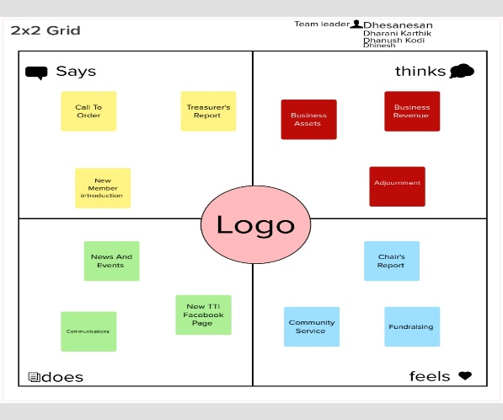

* **ideation & Brainstorming**

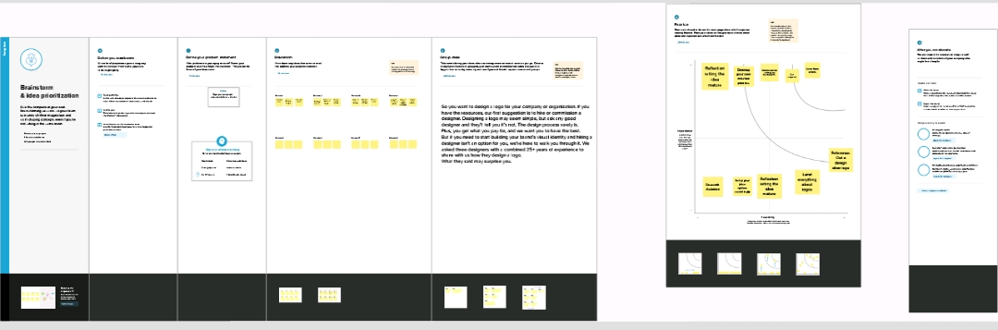

**Result**



**Advantages & Disadvantages**

* It helps to attract customers
* Strong visual impact.

**Applications**

* + Search design for canva.
  + Then select photography design and change the colours and font.

**Conclusion**

* These are the things we have done this project.